**FORMS REACT**

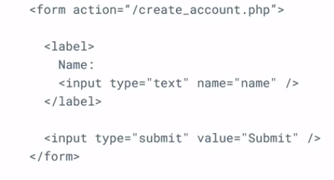

Traditional HTML forms keep some internal state inside the DOM and have some default behavior when submitting them. That's normally done via the action attribute, which points to the endpoint that will handle the request. But what if you would like a more granular level of control? For example, customers of the little lemon restaurant can reserve a table on the website using a form. Imagine if there was a function that could handle the submission of the form and access the data that the user entered into it. That's where controlled components come in**.**

**Controlled components**

They are a set of components that offer a declarative application programming interface or API to enable full control of the state of form elements at any point in time using React state. Rather than relying on the native state from DOM elements, the React state is made the single source of truth, controlling the displayed value of your form elements at all times.



In order to create a controlled component you need to use a combination of local state and value prop

But how do you get updates from any new text character entered in the input? Well for that, you need a second prop to complete the design of your controlled component, the onChange callback.

Example

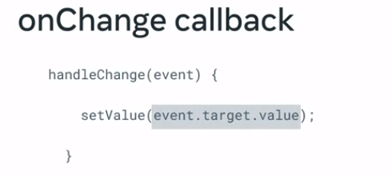

To get the new value from every keystroke, you need to access the target property from the event and grab the value from that object, which is a string.  Finally, to have control over the form values whenever the form is submitted, you can use the onSubmit prop in the form HTML element.

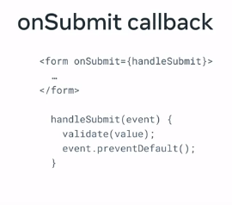

.

Finally, to have control over the form values whenever the form is submitted, you can use the onSubmit prop in the form HTML element. The onSubmit callback also receives a DOM-like event as a parameter. There you can access your form values to perform any desired logic that must take place before submission, for example validating your input values. Also, if you would like to prevent the default HTML form behavior, you need to call event.preventDefault inside your onSubmit callback.

**Controlled components vs. Uncontrolled components**

This reading will teach you how to work with uncontrolled inputs in React and the advantages of controlled inputs via state design. You will also learn when to choose controlled or uncontrolled inputs and the features each option supports.

**Introduction**

In most cases, React recommends using controlled components to implement forms. While this approach aligns with the React declarative model, uncontrolled form fields are still a valid option and have their merit. Let's break them down to see the differences between the two approaches and when you should use each method.

**Uncontrolled Inputs**

Uncontrolled inputs are like standard HTML form inputs:

const Form = () => {

 return (

   <div>

     <input type="text" />

   </div>

 );

};

They remember exactly what you typed, being the DOM itself that maintains that internal state. How can you then get their value? The answer is by using a React ref.

In the code below, you can see how a ref is used to access the value of the input whenever the form is submitted.

const Form = () => {

 const inputRef = useRef(null);

 const handleSubmit = () => {

   const inputValue = inputRef.current.value;

   // Do something with the value

 }

 return (

   <form onSubmit={handleSubmit}>

     <input ref={inputRef} type="text" />

   </form>

 );

};

In other words, you must **pull** the value from the field when needed.

Uncontrolled components are the simplest way to implement form inputs. There are certainly valued cases for them, especially when your form is straightforward. Unfortunately, they are not as powerful as their counterpart, so let's look at controlled inputs next.

**Controlled Inputs**

Controlled inputs accept their current value as a prop and a callback to change that value. That implies that the value of the input has to live in the React state somewhere. Typically, the component that renders the input (like a form component) saves that in its state:

const Form = () => {

 const [value, setValue] = useState("");

 const handleChange = (e) => {

   setValue(e.target.value)

 }

 return (

   <form>

     <input

       value={value}

       onChange={handleChange}

       type="text"

     />

   </form>

 );

};

Every time you type a new character, the **handleChange** function is executed. It receives the new value of the input, and then it sets it in the state. In the code example above, the flow would be as follows:

* The input starts out with an empty string: **“”**
* You type **“a”** and **handleChange** gets an **“a”** attached in the event object, as **e.target.value**, and subsequently calls **setValue** with it. The input is then updated to have the value of **“a”**.
* You type **“b”** and **handleChange** gets called with **e.target.value** being **“ab”**.and sets that to the state. That gets set into the state. The input is then re-rendered once more, now with **value = "ab"** .

This flow **pushes** the value changes to the form component instead of pulling like the ref example from the uncontrolled version. Therefore, the Form component always has the input's current value without needing to ask for it explicitly.

As a result, your data (React state) and UI (input tags) are always in sync. Another implication is that forms can respond to input changes immediately, for example, by:

* Instant validation per field
* Disabling the submit button unless all fields have valid data
* Enforcing a specific input format, like phone or credit card numbers

Sometimes you will find yourself not needing any of that. In that case uncontrolled could be a more straightforward choice.

**The file input type**

There are some specific form inputs that are always uncontrolled, like the file input tag.

In React, an **<input type="file" />** is always an uncontrolled component because its value is read-only and can't be set programmatically.

The following example illustrates how to create a ref to the DOM node to access any files selected in the form submit handler:

const Form = () => {

 const fileInput = useRef(null);

 const handleSubmit = (e) => {

   e.preventDefault();

   const files = fileInput.current.files;

   // Do something with the files here

 }

 return (

   <form onSubmit={handleSubmit}>

     <input

       ref={fileInput}

       type="file"

     />

   </form>

 );

};

**Conclusion**

Uncontrolled components with refs are fine if your form is incredibly simple regarding UI feedback. However, controlled input fields are the way to go if you need more features in your forms.

Evaluate your specific situation and pick the option that works best for you.

The below table summarizes the features that each one supports:

| **Feature** | **Uncontrolled** | **Controlled** |
| --- | --- | --- |
| One-time value retrieval (e.g. on submit) | **Yes** | **Yes** |
| Validating on submit | **Yes** | **Yes** |
| Instant field validation | No | **Yes** |
| Conditionally disabling a submit button | No | **Yes** |
| Enforcing a specific input format | No | **Yes** |
| Several inputs for one piece of data | No | **Yes** |
| Dynamic inputs | No | **Yes** |

And that's it about controlled vs. uncontrolled components. You have learned in detail about each option, when to pick one or another, and finally, a comparison of the features supported.